**Exploring Chronic Disease Prevalence, Cost, & Policy Changes in the US: A Focus on Diabetes**

Javidan Karimli

Jennifer Li

Jahnavi Maddhuri

Rishika Randev

**Stakeholder Note:** *This exploratory report is addressed towards U.S. policymakers exploring the scope and consequences of chronic disease cost interventions, such as members of Congress in the Senate Committee Health, Education, Labor and Pensions. In the exploratory stage, we are focused on presenting information on the most widely impacting chronic diseases as well as their cost trends in recent years.*

# Executive Summary

Chronic diseases carry not only a medical burden, but also a significant financial burden, both from a public policy and an individual perspective. To develop a better understanding of, and find patterns in, the pressing issue of rising healthcare costs in the U.S., in this report we explore three main focus areas: the prevalence of chronic diseases, the role of federal policies in mitigating healthcare costs, and trends in diabetes-related medical expenses at the state and national level. A literature review of studies on chronic disease prevalence reveals that AIDS, diabetes, depression, and Chronic Obstructive Pulmonary Disorder (COPD) are some of the most prevalent chronic diseases in the U.S.; using Disability Adjusted Life Years (DALYs) to estimate burden of disease, Murray and Lopez found that AIDS received 20 times more NIH research funding per DALY than other diseases, while COPD remained severely underfunded in comparison. This indicates that there is a major disparity between research funding and the amount of impact that each chronic disease has. Recent federal policies focused on reducing chronic disease healthcare expenses include the Insulin Cost cap for Medicare patients, as well as drug price negotiations in Medicare that are projected to save $100 billion by 2031.

Finally, through analysis of the trends in diabetes healthcare spending, we find that the medical costs related to diabetes on a national level increased from $465 billion in 2017 to $640 billion in 2021. This translated to a per-person cost increase of nearly $3,000 in this time span, but there was significant state level variation in this increase. Further, of these costs, Medicaid’s share of spending grew from 13% to 23%. We found that the role of Medicaid and Medicare within chronic disease costs is different across the regions in the US. As diabetes costs continue to rise, there is an urgent need for cost reduction interventions, specifically optimized for enhanced patient health outcomes.

# Introduction

Chronic diseases, including heart disease, cancer, and diabetes, are long-lasting conditions (usually one year or more) that require ongoing medical attention, limit activities of daily living, or both. According to the Centers for Disease Control and Prevention (CDC), six in ten Americans have at least one chronic disease, and four in ten have two or more chronic diseases (CDC, 2024). Three of the five leading causes of death and disability in the U.S. belong to this family; in addition, chronic diseases collectively contribute $4.5 trillion to the nation’s annual health care costs.

Given the widespread and continued impact of chronic diseases as well as their economic burden, the study of their prevention and treatment outcomes has become a key area of focus for public health. This report aims to provide an initial survey of chronic disease prevalence and economic implications in the U.S., to pave the way for future work on the causal relationship between healthcare spending and disease outcomes. Through a comprehensive review of existing research as well as our auxiliary data analysis, this report seeks to answer the following questions:

* What are the most prevalent chronic diseases in the U.S., and how are their disease outcomes typically measured?
* What are recent policy changes that have directly or indirectly impacted healthcare costs related to chronic disease in the U.S.?
* How has the cost of diabetes, one of the most prevalent chronic diseases, changed over time at a state and national level?

# Methodology

To answer these three questions, we used a combination of literature reviews and our own analysis. The first two topics were mainly addressed through review of research papers while the third used data wrangling, analysis, and visualization techniques.

The primary research paper we used to understand the prevalence and research funding for chronic disease was *NIH Disease Funding Levels and Burden of Disease.* This study included an analysis of over 25 different diseases, providing details on their prevalence, overall disease burden and the research funding allocated to each by the NIH. The second question was answered through research and review of news articles covering policies that have affected or will affect costs of diseases in the US. These included reports on the Affordable Care Act, initiatives to drastically decrease the cost of 10 drugs vital to disease care, and the Insulin Cost Cap provision in the Inflation Reduction Act.

Finally, to answer our third question, we referenced work by Shrestha et al. and Khavjou et al., which provided two comprehensive analyses of the financial burden of diabetes at the state level across the United States in 2017 and 2021, respectively. In both studies, State Health Expenditure Accounts, the Behavioral Risk Factor Surveillance System, and Centers for Medicare and Medicaid Services Minimum Data Set data were used to generate cost estimates adjusted for their respective years. While cost was broken down in several different ways (direct medical costs, indirect costs due to mortality and productivity loss, etc.), our key focus was on medical costs, both total and per person. The per person cost was calculated as the total medical cost divided by the estimate of adult diabetic population in each state. Shrestha and Khavjou’s estimates also included information on the breakdown of costs between Medicare, Medicaid and other providers. We scraped the publicly available data into CSV files, then used Python (plotly and matplotlib) to plot the trends required to help us understand changes in the cost of diabetes over time.

# Results

*Question 1: What are the most prevalent chronic diseases in the U.S., and how are their disease outcomes typically measured?*

The NIH has done extensive research on existing disease conditions and the impact of these conditions on Americans. In their 2011 study, Murray and Lopez reported that based on 2006 data in North America, diabetes impacted about 21 million people, AIDS about 1.2 million, depression about 8.2 million and Chronic Obstructive Pulmonary Disorder (COPD) about 6.9 million. Surprisingly, they also found that prevalence or burden of disease did not correlate with the NIH’s research funding levels (Murray & Lopez, 2011). Furthermore, even when considering more granular metrics beyond prevalence, like Disability Adjusted Life Years (DALY), there is still a lack of strong correlation. DALY is a standardized measure that considers not only the number of cases for each disease, but also how many years of life are lost due to disability or early death. Murray and Lopez found that there was still misalignment between DALYs and research funding by the NIH: AIDS received more than 20 times the funding per DALY compared to other diseases; diabetes received approximately 2.4 times the funding relative to its burden; depression received over 15 times less funding per DALY compared to AIDS; and COPD was also severely underfunded, despite being a major contributor to disease burden (Murray & Lopez, 2011).

With regard to how the success of public health interventions can be evaluated, incidence (number of new cases), prevalence, and DALYs are often appropriate measures of how impactful an intervention has been in prevention of chronic disease over time. Disease outcomes, on the other hand, can be evaluated using medical diagnosis codes from claims data, number of hospital revisits, self-assessments by patients, and many other options, depending on the nature of the disease (Giannouchos et al., 2024).

*Question 2: What are policy changes that have directly or indirectly impacted healthcare costs related to chronic disease in the U.S.?*

The U.S. government has implemented various policies aimed at addressing the rising costs associated with chronic diseases. These policies focus on improving access to healthcare, enhancing the quality of care, encouraging preventative measures, and managing long-term conditions. Key initiatives, such as the Affordable Care Act (ACA), signed into law in 2010, increased health insurance coverage, expanded people’s access to the Medicaid program, and reduced healthcare costs (U.S. Department of Health and Human Services [HHS], n.d.).

Another major initiative to lower healthcare costs is Medicare’s first-ever negotiation of lower prices for 10 high-cost drugs, including medications for diabetes, cancer, and cardiovascular diseases. The federal government negotiated these price reductions to help curb excessive healthcare spending, with the new prices set to take effect in 2026. The newly negotiated drug prices cover a range of essential medications used to treat blood clotting disorders (blood thinners), diabetes, cardiovascular diseases, arthritis, cancer, and autoimmune conditions. This policy is projected to save Medicare nearly $100 billion by 2031 while also lowering out-of-pocket costs for seniors (Wall Street Journal, 2024).

Regarding diabetes, one policy aimed at reducing the cost burden of diabetes medications is the Insulin Cost Cap provision in the Inflation Reduction Act. This provision establishes a $35 monthly cap on insulin costs for Medicare beneficiaries, benefiting approximately half of the 8.4 million Americans who rely on insulin, especially seniors who have historically faced high out-of-pocket expenses (Abouleinein, 2024). This policy is an important step in making insulin more affordable and improving access to essential medications for those with diabetes.

These initiatives have aimed to tackle the rising costs associated with chronic disease by focusing on prevention, early intervention, and improving long-term disease management.

*Question 3: How has the cost of diabetes changed over time at a state and national level?*

Given the high disease burden of diabetes across the US, its relationship with socioeconomic disparities., and recent changes in pricing for insulin, we were driven to further explore how the cost of this specific chronic disease is distributed and has changed over time. To help answer this question, we used estimates of direct medical costs attributable to diabetes that were created by Shrestha et al. (2018) and Khavjou et al. (2024). The histograms in Figure A below depict the cost distribution for diabetes per adult patient on a state level in 2017 (blue) and 2021 (orange). Both distributions appear mostly normal, with some right skew. What is most notable is that the 50th percentile of the medical cost of diabetes increased by nearly $3000 between 2017 and 2021. On a broader level, the total national cost of diabetes, including both medical and indirect costs due to productivity loss, increased from around $465 billion in 2017 (Shrestha et al., 2018) to $640 billion in 2021 (Khavjou et al., 2024).

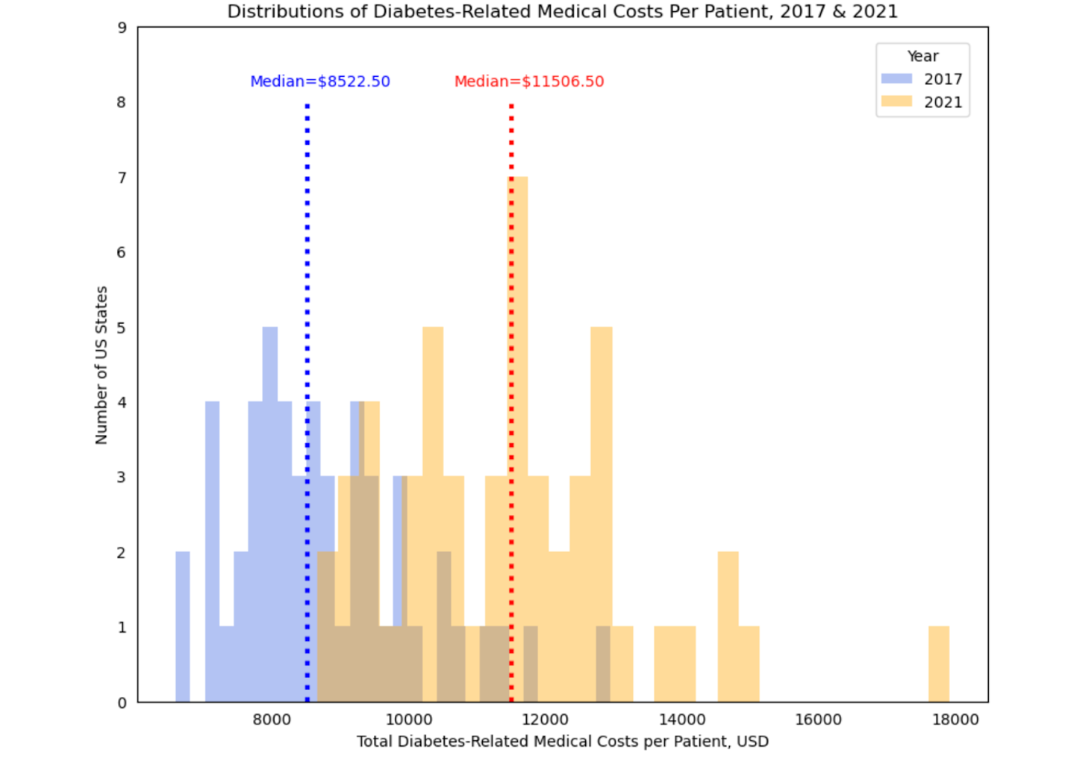

Figure A: This figure displays histograms of diabetes-related medical costs per adult patient in 2017 (blue) and 2021 (orange) across U.S. states. 2017 medical cost estimates are provided by Shrestha et al. (2018) and 2021 estimates by Khavjou et al. (2024); in both years, cost is summed across all player types (Medicare, Medicaid, and other payers). The dashed lines depict the median values for each distribution (2017 median cost = $8522.50 and 2021 median cost = $11506.50)

Understanding how this increase in cost varied by state is a fundamental part of our cost analysis and the answer to this exploratory question, because it can inform the selection of potential hotspot states or regions where the causative effects of cost reduction interventions would be most meaningful to study. To explore this variation, we created a choropleth map shaded by degree of cost increase between 2017 and 2021, as seen in Figure B below. The plot indicates that in states like Colorado, South Carolina and Nevada, the increase in cost per person was only approximately $1,500. However, in the District of Columbia and New York, this increase was much larger, closer to $4,500 and $5,000 per person respectively.

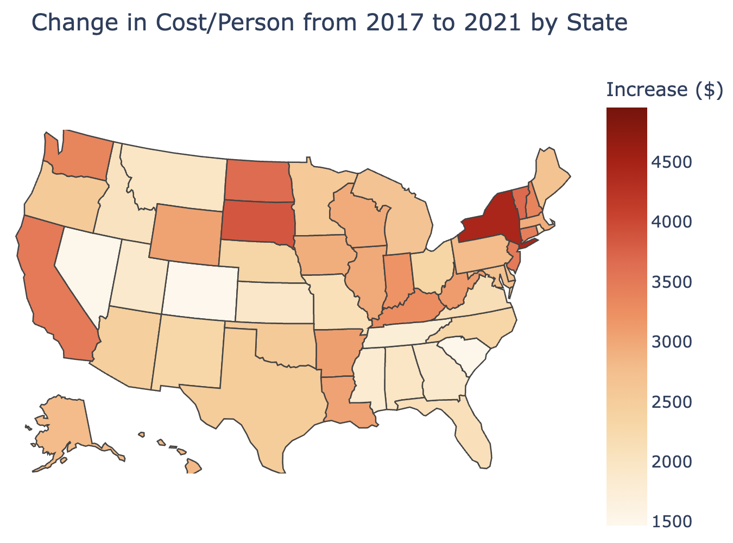

Figure B: The geo-plot above shades each U.S. state based on the increase in total medical cost per diabetic patient in the state. We see that from 2017 to 2021, New York experienced one of the largest increases in costs with an increase of $4441/person.

Beyond an exploration of state variation in overall diabetes-related medical cost increases, understanding the diabetes cost trend in the U.S. also warranted a more granular analysis of how these costs were distributed between Medicare, Medicaid, and other insurers in 2017 vs. 2021. Figures C and D depict these breakdowns for both 2017 and 2021 at a national level. Medicare consistently covered around one-third of total costs, with a slight increase from 34.45% in 2017 to 34.82% in 2021, indicating its stable role in supporting diabetes-related expenses. Medicaid, however, saw a significant rise in its share, increasing from 13.38% in 2017 to 22.87% in 2021. This substantial growth suggests a greater reliance on government assistance, possibly due to increased Medicaid enrollment or policy changes. Meanwhile, the 'Other' category—which includes out-of-pocket payments and private insurance—declined from 52.16% in 2017 to 42.31% in 2021 (Khavjou et al., 2024). This shift implies that a smaller proportion of diabetes-related costs were covered by private sources, reinforcing the increasing dependence on public healthcare programs.

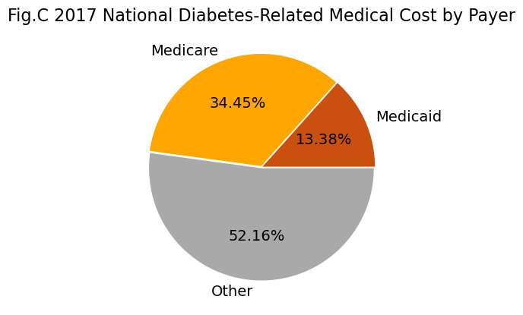

Figure C: This pie chart shows the percentage of total diabetes-related medical costs across the US that were paid by each payer type in 2017 based on data from Shrestha et al. (2018). The 'Other' category, which accounts for over half of the cost, includes out of pocket payments and private insurance.

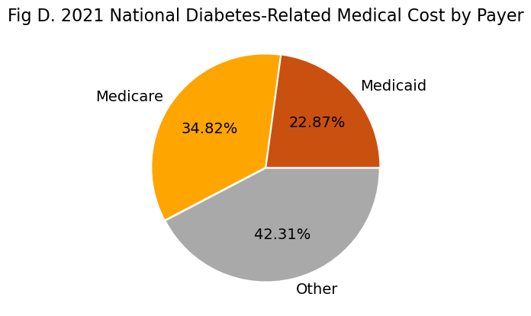

Figure D: This pie chart shows the percentage of total diabetes-related medical costs across the US that were paid by each payer type in 2021 based on data from Khavjou et al. (2021). The ‘Other’ category includes out of pocket payments and private insurance, and covers around 42% of the cost in 2021, a smaller slice than in 2017. By contrast, the proportion of the cost covered by Medicaid increased from 14% in 2017 to 23% in 2021.

The last part of our cost trend analysis included an exploration of regional variations in how payer type distribution has changed over time. The bar graph below (Figure E) depicts the total diabetes cost by payer type in different regions for 2017 (left) and 2021 (right), with Medicare and Medicaid grouped together for a more general view of public vs. private payers. The South Atlantic region exhibited the highest total diabetes-related medical cost in 2021, surpassing $60 billion. In 2017, it was among the regions with the highest expenditures, alongside the Middle Atlantic and Pacific regions. The graph illustrates a noticeable increase in costs across all regions from 2017 to 2021, with the South Atlantic and Middle Atlantic experiencing one of the most significant rises. While the increase in expenditures is present across both payer categories for all regions, some regions saw a more substantial increase in private costs than public, and vice versa; this highlights that the growing financial burden of diabetes care in the U.S. cannot be ameliorated by a one-size-fits-all approach, and rather requires multi-pronged cost reduction interventions targeting different sources of cost as well as patients that rely on different payer types.

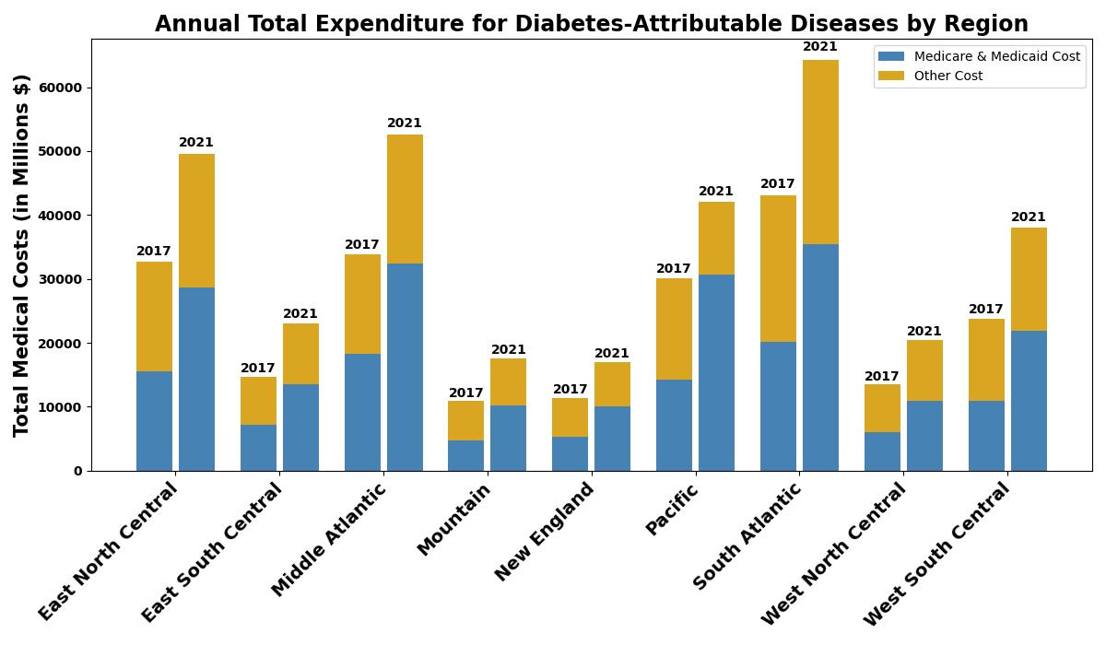

Figure E: This stacked bar chart displays the total diabetes-related costs across different regions in the U.S. for 2017 and 2021 based on the data by Shrestha et al (2018) and 2021 estimates by Khavjou et al (2024). The left bar in each region represents 2017, while the right bar represents 2021. The blue color indicates the total cost for Medicare and Medicaid, while the orange color represents the total cost paid for by other payers (out of pocket and private insurance). The South Atlantic region led in total costs in 2017 and surpassed $60 billion in annual expenditure by 2021.

# Conclusion

This report provides an initial overview of the problem space around chronic disease prevalence and cost. Past research indicates both large burdens of disease for AIDS, diabetes, depression, and COPD in the U.S., and significant disparities between these burdens and the amount of research funding and attention directed towards each disease. In addition, various sets of federal policies have directly or indirectly attempted to lower the expense of living with a chronic disease for everyday Americans through increased coverage, price caps, and pharmaceutical negotiations; however, they continue to cost our country a whopping $4.5 trillion annually. The overall trend between 2017 and 2021 indicates a significant increase in spending across all payer types–Medicare, Medicaid, and private insurance. However, Medicaid paid for a greater portion of total national diabetes-related medical cost in 2021 than it did in 2017, while other insurers paid for a smaller portion. The growing role of Medicaid in covering diabetes-related expenses emphasizes the need for Medicaid-focused cost reduction interventions and policy considerations that prioritize the program’s funding and sustainability.

There are also notable state and regional variations in the medical cost of diabetes, with the South and Middle Atlantic regions experiencing the highest increase in diabetes cost in this interval and also leading the U.S. in diabetes cost in 2021. While promising, the answers explored to the three initial questions are limited temporally, as data could only be obtained for two specific years and was based on estimates from other studies; increasing the time frame and gaining access to data from every year could yield a more nuanced analysis of the cost trend.

These findings underscore both how severe the economic consequences of a chronic disease diagnosis are, and how these consequences may pose barriers to treatment and successful outcomes for Americans living with chronic disease. On the other hand, they also provide further opportunity for cost reduction interventions at a federal level. However, to determine the likelihood of success for such an intervention, the next step would be a causative study exploring how previous policies aimed at reducing healthcare spending for chronic disease patients, specifically diabetes patients, have affected patient outcomes, similar to insulin cap research done by Giannouchos et al. in 2024. The results from our study can then be used to inform the design of future cost reduction interventions and their expected impact.

# References

Centers for Disease Control and Prevention (CDC). (2024, October 4). About chronic diseases. Centers for Disease Control and Prevention.<https://www.cdc.gov/chronic-disease/about/index.html>

Giannouchos, T. V., Ukert, B., & Buchmueller, T. (2024). Health Outcome Changes in Individuals With Type 1 Diabetes After a State-Level Insulin Copayment Cap. *JAMA network open*, *7*(8), e2425280. https://doi.org/10.1001/jamanetworkopen.2024.25280

Khavjou, O. A., Sun, M., D'Angelo, S. R., Neuwahl, S. J., Hoerger, T. J., Cho, P., Myers, K., & Zhang, P. (2024). Economic Costs Attributed to Diagnosed Diabetes in Each U.S. State and the District of Columbia: 2021. *Diabetes care*, dc240832. Advance online publication. <https://doi.org/10.2337/dc24-0832>

Murray, C. J. L., & Lopez, A. D. (2011). NIH disease funding levels and burden of disease. PLOS ONE, 6(2), e16837. <https://doi.org/10.1371/journal.pone.0016837>

Sundar S. Shrestha, Amanda A. Honeycutt, Wenya Yang, Ping Zhang, Olga A. Khavjou, Diana C. Poehler, Simon J. Neuwahl, Thomas J. Hoerger; Economic Costs Attributable to Diabetes in Each U.S. State. *Diabetes Care* 1 December 2018; 41 (12): 2526–2534. <https://doi.org/10.2337/dc18-1179>

U.S. Department of Health and Human Services. (n.d.). *About the Affordable Care Act*. U.S. Department of Health and Human Services.<https://www.hhs.gov/healthcare/about-the-aca/index.html>

Wall Street Journal. (2024, August 15). *Medicare negotiated lower prices for these 10 drugs*. Wall Street Journal.<https://www.wsj.com/health/pharma/medicare-prescription-drugs-lower-prices-e8eceeb7>

Abouleinein, A. (2024, October 30). $35 insulin: Who in the US benefits? *Reuters*. <https://www.reuters.com/business/healthcare-pharmaceuticals/who-us-benefits-35-insulin-2024-10-30/>